Karnatak Law Society’s

GOGTE INSTITUTE OF TECHNOLOGY

Department of Computer Science and Engineering

Udyambag Belagavi -590008

Karnataka, India.



Open Book Assignment-1 on

Rooftop Solar PV Plant

Submitted for the requirements of 5th semester in O.E

For Renewable Energy Sources (18EEOE561)

Submitted by

NAME USN

1) Atreay Kukanur 2GI19CS028

2) Om Shintre 2GI19CS126

3) Fakkiresh Noorshetter 2GI19CS041

4) Ramesh M P 2GI19CS110

**Under the guidance of**

**Prof. Rahul Suryavanshi**

**Asst. Prof., Dept. of EEE**

**Academic Year 2021-22 (Odd semester)**

**KLS Gogte Institute of Technology, Belagavi**

**Department of Electrical & Electronics Engineering**

**Academic Year: 2020-21(ODD SEM)**

**Program: B. E Semester: 5**th

**OBA – I**

**Course Title: Renewable Energy Sources Code:** 18EEOE561

**Max. Marks:** 10 marks **Duration:**1 week **Date:**16/12/2020

**1. Discuss in detail, any one case study of a rooftop solar PV plant**

ABSTRACT

The objective of this project work is to analyze the performance of a 100kw capacity solar panel installed in Sir Visveswaraya institute of technology College of Engineering. Use of electricity is increasing day by day. The electricity finds its application in all the domains. Converting solar energy into electrical energy is one of the best ways to reduce fossil fuel consumption. Owing to the cost and efficiency of the solar cells, it is not used in most of the electrical applications. By detailed analysis of plant we could determine the various performance aspects and make or recommends changes accordingly to improve the efficiency and utilization of plant optimally. The project includes the comparison of the current electricity bill with the bill before installation of solar panel system and conducting detailed analysis to understand Energy consumption (kWh). The third phase includes the study of the direct and indirect advantages of installing a solar panel in this institution for e.g. bill savings, tax savings and power being supplied back to the grid.

INTRODUCTION

The solar power generating system supplied by Tata Power Solar is troublefree, long-lasting and cost effective power solution. Non-availability of grid power, Unpredictable power cuts, rising power bills and maintenance worries are history. As a result of proven technology, they are highly efficient and maintenance free. With just a onetime investment, Solar Power Packs send your non-availability of grid power, unpredictable power cuts & rising electricity bill worries packing. What’s more, they are eco-friendly too! Solar PV modules produce DC electricity. They may be used in single-module and multiple-module systems to meet the current or voltage requirements of a wide range of applications with its nominal power, it’s well-suited to utility grid systems and traditional applications of photovoltaic such as Telecommunications, grid connect and standalone systems. Inverter does the function of converting DC energy produced by Solar modules to AC energy along with many other supporting operations required for proper functioning of solar power system & export power to Grid.

AC Distribution board is used to connect the output of inverter at one common point and Output of ACDB to be connected to Existing LT Panel at site. ACDB is also used to monitor the output parameters at on Considering the good potential of Solar Power and also the trust given by the Central & State Government in utilizing the abundant Solar Power in the State of Maharashtra for Power generation, Bapuji International School is proposing to set upto 100KW Roof Top Solar PV based Power Plant in Karnataka state. The Plant and equipment facilities will be designed to comply with all applicable stipulations / guidelines of statutory authorities such as State and Central Pollution Control Boards, Electrical Inspectorate. This report highlights the details of the proposed Power generation scheme, site facilities, features of the main plant, electrical systems evacuation of generated power, environmental and safety aspects, distribution mechanism, Cost estimation, risk mitigation plan and Project viability. It also highlights the complete schedule for the project implementation.

PROJECT STAGES

1. SYSTEM COMMISSIONING STUDY
2. PERFORMANCE ANALYSIS
3. INNOVATIVE CHANGES
4. ELECTRICITY BILL COMPARESION
5. DETERMINE DIRECT AND INDIRECT ADVANTAGES

SYSTEM COMMISSIONING STUDY

PROJECT: Design, manufacture, Supply, installation and commissioning of 100 KW Solar Photovoltaic Grid Connect systems

|  |  |  |
| --- | --- | --- |
| **1** | Name of the Company | TATA SOLAR POWER SYSTEMS LIMITED #78, ELECTRONICS CITY BANGLORE560100,INDIA |
| **2** | Proposed Project Location | Badagandi, Tq: Bilgi, Dist: Bagalkot |
| **3** | Power Plant capacity | 100KW |
| **4** | Technology | Solar Photovoltaic |
| **5** | System type | Grid connect Solar PV system |
| **6** | Type of Module proposed | Multi Crystalline |
| **7** | Type of Inverter proposed | Grid tie centre Inverter |
| **8** | Total Inverter capacity | 3 units each 30kw |
| **9** | Single panel output | 255W |

MODEL

Total plant divided in two part

* 68kw plant-

: 267 module

: two 30kw inverter

: Tilt angle 15 degree

* 32kw plant-

: 127 module

: One 30kw inverter

: Tilt angle 15 degree

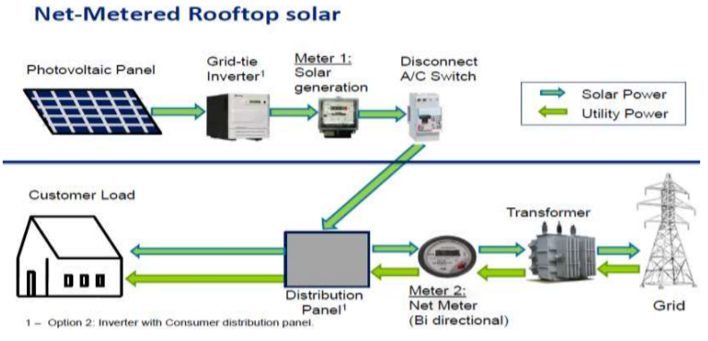BLOCKDIAGRAM

LIST OF COMPONENTS

|  |  |  |  |
| --- | --- | --- | --- |
| **Sr.No** | **Description** | **Qty** | **Unit** |
| 1 | 250Wp Solar Module Mono | 400 | Nos. |
| 2 | String Inverter 11KW | 5 | Nos. |
| 3 | PV Junction Box | 10 | Nos. |
| 4 | Module Mounting Structure | For 50KWp | Sets |
| 5 | DC Cable 1C x 4Sq.mm | 1000 | Mtrs. |
| 6 | AC Cable 4 C of 6sqmm armour Cu cable | 25 | Mtrs. |
| 7 | AC Cable 4C of 70sqmm armour Alu cable | 100 | Mtrs. |
| 8 | DC earthing kit | 1 | Set |
| 9 | Lightning Arrestor | 1 | Set |

Specifications:

**1. No of panels required for 100 Kw Solar PV system:**

If one solar panel rates about 250 Watts, then No. of panels required for 100kw,

= 100 * 1000/250 = 400, 400 solar PV panels.

**2.** **Area:** Area requirement for 1 Kw power generation by solar PV system , = 100 Sq ft (shadow free area) Area required for 100 Kw power generation by solar PV system = 100*100 = 10000 sq ft (shadow free area).

**3. Number of units generated by 1kw solar PV system assuming 5 Hrs of bright sun in a day,**

(Energy = Power * time = Kw*Hr) = 1Kw * 5hrs = 5Kwh

= 5 Units/day for 100kw solar PV system,

= 100kw * 5hrs = 500 Kwh = 500 Units/day

**4. Amount of electricity bill saved using 100 kw solar PV system**

Assuming cost of 1 unit electricity = 7 Rs Electricity bill saved/day = units generated in a day * cost of 1 kwh (unit) = 500 kwh * 7 Rs = 3500 Rs Monthly electricity bills saved, = 3500 Rs * 30days = 1,05,000 Rs Yearly electricity bill saved, = 1,05,000 Rs * 12months = 12,60,000 Rs.

**5. Return of investment of solar panel/Payback calculations**

If cost required for 1Kw of Solar PV system installation is 62000 Rs, then cost required for 100 Kw of Solar PV system installation = 62000 * 100Kw = 62,00,000 Rs.

As per consumer, 30% subsidy is allowed on solar PV system installation After 30% subsidy, the total cost of 100Kw solar PV system installation comes to: = 30/100 * 6200000 Rs = 18,60,000 Rs (subsidy discount)

**Net initial cost of The System = 62,00,000 – 18,60,000 = 43,40,000 Rs**

**6. Payback period** = net cost of the system / yearly savings

= 43,40,000/12,60,000 Rs

= 3.44 (3 yrs. & 4 months) – **RECOVERY PERIOD**

Picture of rooftop solor pv plant in collage:

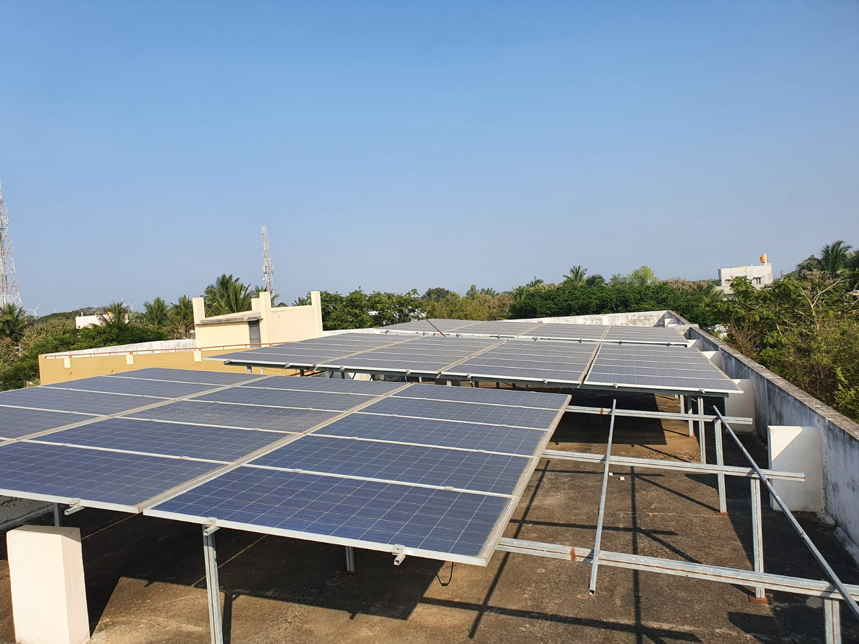

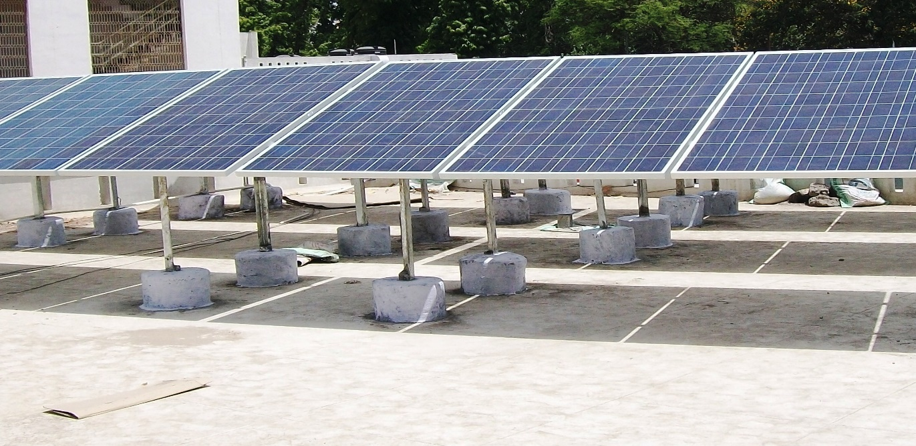

|  |  |  |  |  |
| --- | --- | --- | --- | --- |
| **Sr.no.** | **Month** | **Measured Energy (MWH)** | **PR ( IN %)** | **CUF( IN %)** |
| 1 | JAN | 3.37 | 52 | 0.38 |
| 2 | FEB | 4.159 | 64 | 0.47 |
| 3 | MAR | 3.63 | 56 | 0.41 |
| 4 | APR | 3.63 | 56 | 0.41 |
| 5 | MAY | 2.59 | 40 | 0.29 |
| 6 | JUN | 3.31 | 51 | 0.37 |
| 7 | JUL | 4.02 | 62 | 0.45 |
| 8 | AUG | 2.92 | 45 | 0.33 |
| 9 | SEPT | 3.119 | 48 | 0.35 |
| 10 | OCT | 3.5 | 55 | 0.40 |
| 11 | NOV | 3.89 | 60 | 0.44 |
| 12 | DEC | 4.54 | 70 | 0.51 |
|  |  | 3.55 | 54.91 | 0.36 |

PERFORMANCE ANALYSIS

Capacity utilisation factor = Energy measured in (kwh) / (365*24*installed capacity)

Performance ratio = Energy measured in (kwh) / (Generated energy *Active area* module efficiency)

**Performance statistics of year 2016**

PERFORMANCE GRAPH

KEY FINDINGS

* **Proper distance between inverter and panel**

The distance between panel erected and the inverter is proper which reduces high dc power losses in cable. Shorter the cable length less is the power losses so inverter to panel distance is kept small.

* **Proper selection of module technology**

Efficiency and performance of plant also depends upon the module technology selected. The selected technology is PHOTOOVOLTAIC which is cost effective and efficient.

* **Less optimisation due to fixed tilt angle**

The plant commissioned is at fixed tilt angle 15 degree so we cannot optimise plant at its full efficiency. This we can see in performance analysis.

* **Inverter down time should consider**

As this plant is grid connected due various power quality aspects inverter trips too frequently which increases the down time of plant results in poor optimization.

* **Operating tempreture should consider**

Regardless of other seasons in summer the operating tempreture of PV cells crosses the critical operating tempreture which will reduces the efficiency of plant due to semiconductor loss.

* **Storage system unavailable**

The plant grid connected so plant is only useful in day time .In night campus needs to depend on MSEB supply as there is no storage system.

* **Improper spacing between modules- effect of shadow**

The plant erected does not meet the specific distance a measurement so there is shadow effect occurs on panel. So afternoon 2 hours energy generation affected by this shadow effect

INNOVATIVE CHANGES

1. Use of maximum power point tracking
2. SPWM Technique for inverter
3. Proper distance between solar panel
4. Storage system
5. **Use of maximum power point tracking:**

By using the maximum power point tracking the efficiency of plant will be increase ,table shows the actual effect of MPPT on solar power plant. For this proof we studied one MPPT project and we took actual one day readings for our reference as below.

|  |  |  |  |
| --- | --- | --- | --- |
| SR.No | TIME | STATIC READING(WATT) | MPPT.READING (WATT) |
| 1 | 9.3 | 6.33 | 7.5 |
| 2 | 10 | 5.6 | 11.33 |
| 3 | 10.3 | 8.72 | 11.34 |
| 4 | 11 | 8.69 | 10.3 |
| 5 | 11.3 | 8.49 | 11.1 |
| 6 | 12 | 8.11 | 10.2 |
| 7 | 12.3 | 9.3 | 11.8 |
| 8 | 1 | 9.05 | 11.45 |
| 9 | 1.3 | 9 | 10.95 |
| 10 | 2 | 8.75 | 10.7 |
| 11 | 2.3 | 8.6 | 10.56 |
| 12 | 3 | 8.6 | 10.41 |
| 13 | 3.3 | 7.1 | 9.65 |
| 14 | 4 | 7.49 | 9.1 |
| 15 | 4.3 | 6.5 | 7.44 |
| 16 | 5 | 6.75 | 7.49 |
|  | AVERAGE | 8.13W | 10.1444W |

So the readings shows by maximum power point tracking 24.77 % of efficiency increases. So this could be the most economical solution for better performance of plant.

1. 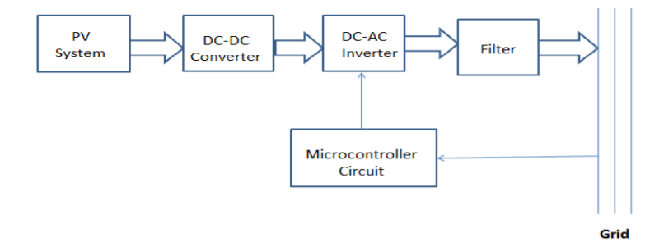**SPWM** **Technique** **for** **inverter**

The block diagram shows advanced technique for inverter which is used for grid connected solar power plants. During detailed analysis we came to find inverter down time for most of the periods which decreases overall plant efficiency. Due to this solution following objectives are fulfilled.

To design and implement switching strategy for inverter application which are simple, reliable, low cost and high efficiency.

To design gate pulse switching of grid tie inverter with SPWM and microcontroller. So this can be implemented at our project site due to following crucial advantages

1. Increases efficiency of inverter.
2. Output parameters synchronises with grid properly.
3. Pure sinusoidal output.
4. Reduced THD. (total harmonic distortion).
5. Real time control without change hardware.
6. **RECOMMISSIONING OF PV MODULES**

The plant erected does not meet the specific distance a measurement so there is shadow effect occurs on panel. So afternoon 2 hours energy generation affected by this shadow effect. This problem could be overcome by only one solution that is recommissioning of PV modules. Almost 30% part of solar cell is affected by this shadow effect 2 hours daily. Hence we suggest repeat errection of PV modules according to specific measurements.

1. **STORAGE SYSTEM**

The whole 100 kw solar power plant is grid connected hence we could use this generated energy only in day time. For remaining hours of day campus still needs MSEB Supply for required electricity consumptions. Hence main objective of project can’t be fulfilled i.e. independency from MSEB SUPPLY. Hence we propose one change in current system The large one model (68kw) should remain as grid connected . And make small unit (32 kw) as stand by So does second unit will store sufficient amount of energy in day time which can be used at night hours of campus energy demands. The storage system can be of conventional battery type or can employ new innovative systems such as flywheels, super capacitors etc.

ELECTRICITY BILL COMPARISON

Before the installation of solar power plant average monthly electricity bill of campus will be 3 lakhs per month, after the installation of solar power plant monthly electricity bill will be decrease

AVERAGE SAVING PER MONTH = BILL BEFORE INSTALLATION –BILL AFTER INSTALLATION

**Energy bill of last six month as shown in table**

|  |  |  |  |
| --- | --- | --- | --- |
| SR .NO | MONTH | UNIT IN KWH | COST IN RS |
| 1 | July | 16132 | 173088 |
| 2 | August | 18080 | 190593 |
| 3 | September | 20527 | 187731 |
| 4 | October | 23153 | 207535 |
| 5 | November | 20600 | 195932 |
| 6 | December | 18787 | 179620 |
|  | Average | 19546.5 | 190000 |

**Average saving per month = 300000 – 190000**

**= 110000 RS**

DIRECT AND INDIRECT ADVANTAGES

1. Clean and eco-friendly energy
2. Negligible maintenance
3. Optimum use of solar energy
4. Efficient use of rooftop
5. Improves performance of plant
6. Cost saving
7. Return period decreases
8. Energy independency

CONCLUSION

* Efficiency of plant can be improved by above proposed techniques about 15 to 30 percentage.
* Thus the college campus can look forward towards full independency from MSEB supply.
* While implementing the improvement techniques capital cost increases but return period is significantly decreases which is indirectly beneficial.
* Although it good earning potential to college by giving extra energy to grid through net metering by increasing current energy generation.

REFERENCES

* TATA SOLAR POWER SYSTEMS User mannuals
* NoppadolKhaehintung and PhaophakSirisuk, “Application of Maximum Power Point Tracker with Self-organizing Fuzzy Logic Controller for Solarpowered Traffic Lights,” IEEE, 2007.
* C.Thulasiyammal and S Sutha, “An Efficient Method of MPPT Tracking System of a Solar Powered Uninterruptible Power Supply Application,” 1st International Conference on Electrical Energy Systems, 2011.